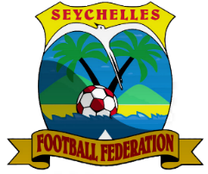
SEYCHELLES FOOTBALL FEDERATION

Insert
Club Logo
SFF CLUB LICENSING FORM F.03.2
NO PAYABLES OVERDUE TOWARDS FOOTBALL CLUBS
ARISING FROM TRANSFER ACTIVITIES
SEASON 2026/27

Date: ___________________

To: CEO
Seychelles Football Federation
Maison de Football
Roche Caiman
Mahé

Dear Sir,

Subject: No payables overdue towards football clubs arising from transfer activities

We, ____________________________________________, a duly registered Football/Sports Club under the Associations Act 2022 (Section 3) hereby confirm our intention to participate in football competitions organized by the Seychelles Football Federation (SFF) for the season ____2026/2027_____.

We further confirm that the Club has no payables overdue towards Football Clubs arising from transfer activities as at ___31 March 2026___.

However, in the case of overdue payables, shown in the Audited Financial Statements presented at the end of (2025) and/or in the interim period ending on the 31 March 2026, we are hereby submitting:
- Proof that these overdue payables have now been settled; and/or
- A written agreement that has been concluded with the creditors in order to extend the deadline for payment of these overdue payables; and / or
- Proof that proceedings have been opened with a competent body according to National legislation or proceedings with the Statutory National or International Football Authorities regarding these payables.
(Relevant Documents Attached)

We hereby confirm that this declaration is validated by an Authorized Signatory no more than 3 months prior to the corresponding deadline for its submission to the SFF.

Sincerely,

________________________________ ________________________________
President General Manager

________________________________ ________________________________
On behalf of Club On behalf of Club

________________________________ ________________________________
Date Date

